DNA-Based Self-Propagating Algorithm for Solving Bounded-Fan-In Boolean Circuits
Mitsunori Ogihara, and Animesh Ray
In Thrid Conference on Genetic Programming, pp. 725-730, 1998
Abstract
This paper proposes a method for simulating Boolean circuits based on primer extension and DNA cleavage. The method could in principle allows simulation of many levels of large Boolean circuits in a single test tube.
Introduction
1、Primer-Extension
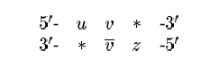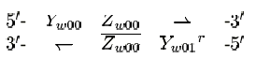
2、Self-propagating circuit simulation with Primer-Extension
A=5-XY-3 A’=5-WY-3 B=5-MY^{c}-3 B’=5-NY^{c}-3 g1= MS^{c} -5 and NS^{c}-5

AB A’B AB’ A’B’
5-XY * 5-WY * 5-XY * 5-WY *
*Y^{c}M-5 *Y^{c}M-5 *Y^{c}N-5 *ỸN-5

5---YM^{c} 5---YN^{c}
g1= MS^{c} -5 and NS^{c}-5
=>5---YM^{c}S--3 5---YN^{c}S—3

3、Check if S exits produced by cutting the cleavage site with Taq1

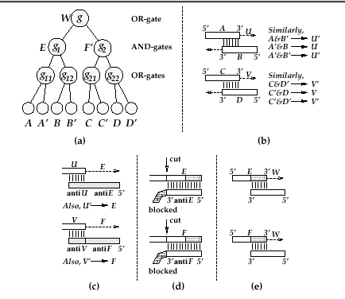

Created by : Hung-Yuan Wang
Date : Nov. 6, 2001

